Who Builds Federal AI?
  - Vendors, Pilots, and the Technical Workforce, 2024–2026
  - PPOL 5202 Project Proposal
Guo (Nora) Zhan
2026-09-21

1. Policy Problem, Audience, and Decision
In 2024, federal agencies hired about 460 technical and data staff a month. From February 2025 to April 2026, they hired about 50 a month. Meanwhile, reported AI use cases rose from 2,133 in the 2024 OMB inventory to 3,611 in the 2025 inventory. Federal AI kept growing while the government stopped hiring the people who could build it in-house. That raises a question neither trend answers alone: who builds federal AI, and does it get past the pilot stage?
The question matters because OMB’s 2025 guidance (M-25-21) asks agencies to accelerate AI use while keeping the capacity to test and monitor high-impact systems. An agency that buys its AI needs different internal skills from one that builds it.
Client and audience. The hypothetical client is the Partnership for Public Service, a nonpartisan nonprofit that trains federal leaders and briefs congressional oversight committees. The audience is its research team and the committee staff it advises.
Decision supported. The product should help the client decide where to focus its advice on building AI capacity: which agencies rely most on vendors, which kinds of AI stall before deployment, and which technical occupations have the thinnest pipeline of new staff.
Analytical questions.
- Who builds the AI agencies run, vendors or agency staff, and how does this vary across agencies and types of AI?
- Which policy areas dominate each agency's AI portfolio, and how concentrated are agencies in one or two kinds of work?
- Which vendors appear most often across federal AI use cases, and how many agencies rely on them?

2. Data Viability
Two public federal sources carry the project: the OMB Federal Agency AI Use Case Inventories and OPM Federal Workforce Data. code/01_download_data.Rmd downloads them, and code/02_build_data.Rmd produces two master analysis tables, ai_use_cases.csv and workforce.csv. The Tableau workbook uses three chart-specific CSVs—make_or_buy.csv, agency_topics.csv, and vendor_concentration.csv—all reshaped from ai_use_cases.csv so that each view has the row structure and field types it needs. These are derived tables, not additional data sources. README.md documents the workflow and the within-OMB year-link key.
Data viability, source 1
 | OMB Federal Agency AI Use Case Inventories
Producer, URL | Office of Management and Budget; github.com/ombegov/2025-Federal-Agency-AI-Use-Case-Inventory and the 2024 repository
Unit | One AI use case reported by an agency.
Coverage | Federal civilian agencies (Department of Defense and intelligence agencies not included); inventory years 2023, 2024, 2025.
Size | 710 × 10 (2023); 2,133 × 62 (2024); 3,611 × 36 (2025), plus 900 records of commercial off-the-shelf products.
Key variables | development_stage (pre-deployment, pilot, deployed, retired): the lifecycle question. contracting_usage (vendor, in-house, or both) and vendor_name: the make-or-buy question. classification (classical machine learning, generative AI, agentic AI, and others). agency. use_case_name (the only way to link records across years).
Limitations | Self-reported, so counts reflect reporting practice as well as adoption (NASA went from 18 cases to 425). The schema changes every year, and there is no stable use case ID, so 2024 and 2025 records must be linked by name. contracting_usage is required only for pilot and deployed cases; within those, 36 of 1,480 are blank, including all of GSA’s. USAID reported 137 cases in 2024 and none in 2025 because the agency was dissolved.
Join | The 2024 and 2025 inventories are linked by use case name within agency; the match is saved as a join key, data/keys/use_case_link_2024_2025.csv. The OMB data are not merged with OPM data.
Access | Confirmed: CSVs, data dictionaries, and OMB’s standardization reports downloaded.

Data viability, source 2
 | OPM Federal Workforce Data (FWD)
Producer, URL | U.S. Office of Personnel Management; data.opm.gov/get-data/data-downloads (API: data.opm.gov/api/v1/files)
Unit | Employment: one employee on the last day of a month. Accessions and separations: one personnel action.
Coverage | Federal civilian executive branch, all states and overseas duty stations. Files back to 2005; downloaded January 2024 to July 2026.
Size | About 2.0–2.3 million rows × 64 columns per headcount snapshot; 31 monthly accession and 31 monthly separation files (69 columns).
Key variables | occupational_series (identifies data scientists, series 1560, and other technical occupations), length_of_service_years (how new the staff are), separation_category and drp_indicator (how people left, including the Deferred Resignation Program), department_code (which agency).
Limitations | Excludes USPS, intelligence agencies, TVA, and Federal Reserve Board staff. Several Department of Defense components did not submit June and July 2026 data, so the project excludes DoD throughout, which also matches OMB’s coverage. The data science series was created in 2021, so many data scientists still sit in other series. Monthly files are revised; the scripts keep only the current version.
Join | None. OPM files are combined only with each other (headcount snapshots, hires, and exits), and are not merged with OMB data.
Access | Confirmed: 31 accession files, 31 separation files, and 5 headcount snapshots (Parquet, about 380 MB).
Fit matters more than size. The OMB inventory is the only systematic record of the AI federal agencies say they run, and it asks who built each system. OPM data record every hire and exit, so the technical workforce can be followed month by month. The two sources are used side by side and never merged: they measure different units, and an agency-level join would invite a causal reading the data cannot support.

3. Proof-of-Concept Visualizations
Each prototype tests one question with a different chart type. These figures were exported directly from the submitted Tableau workbook (proposal/prototypes_tableau_native.twbx).
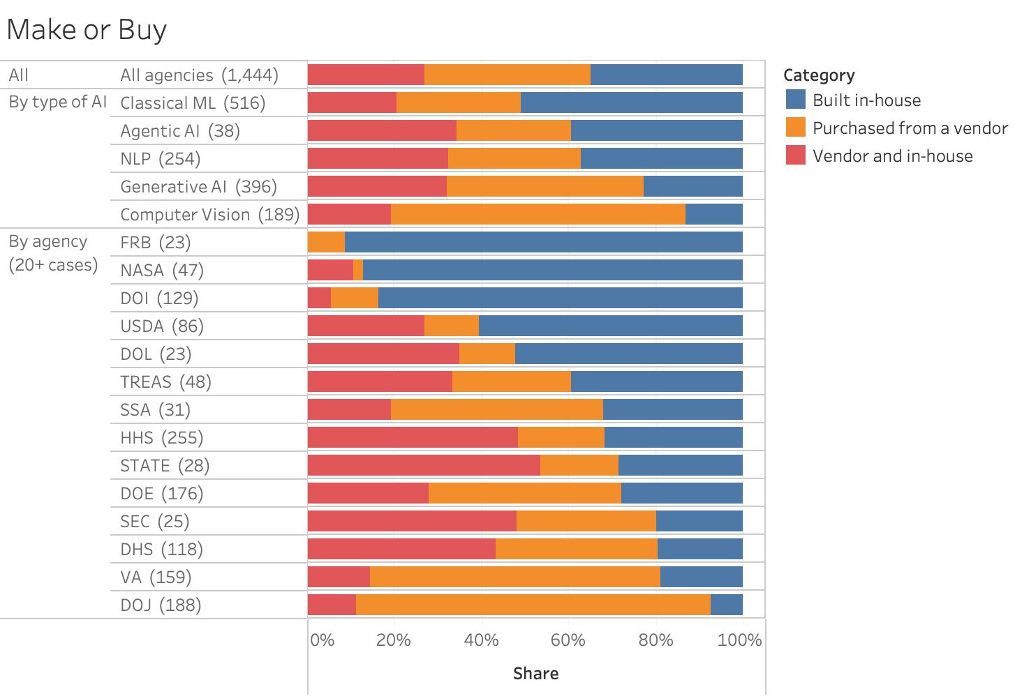
Prototype 1 (100% stacked bar), question 1. Among 1,444 pilot and deployed use cases, 38% were purchased from a vendor, 27% combined vendor and in-house work, and 35% were built in-house. The overall average hides sharp differences: the Department of Justice purchased 81% of its AI, while NASA built 87% of its AI in-house. The uncertainty is that the field records who developed a system, not who maintains it.
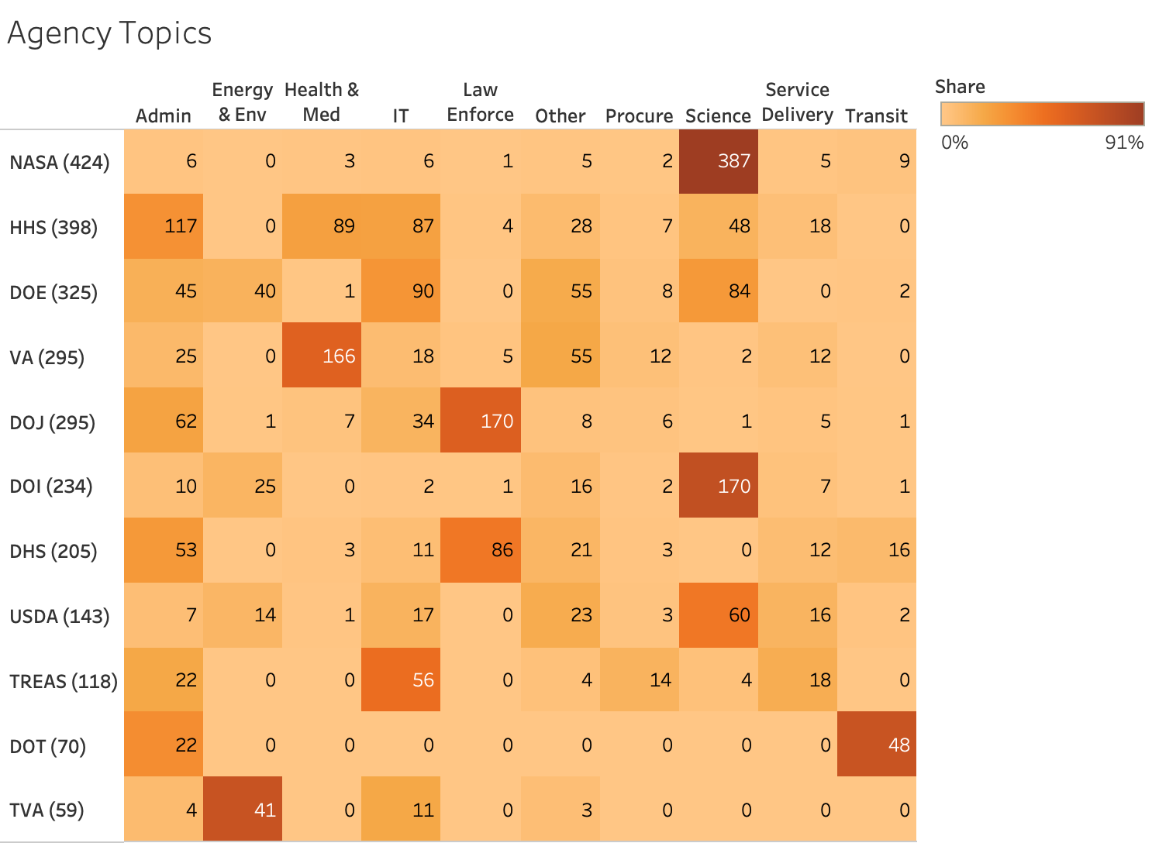
Prototype 2 (heatmap), question 2. Most agencies concentrate their reported AI in one or two policy areas. NASA reported 387 of its 424 classified use cases in science; the Department of Justice reported 170 of 295 in law enforcement; and the Department of Veterans Affairs reported 166 of 295 in health and medical work. Cell labels show counts, while color shows the share of each agency's portfolio. The uncertainty is that agencies assign their own topic labels, and cases with missing topic information are excluded.
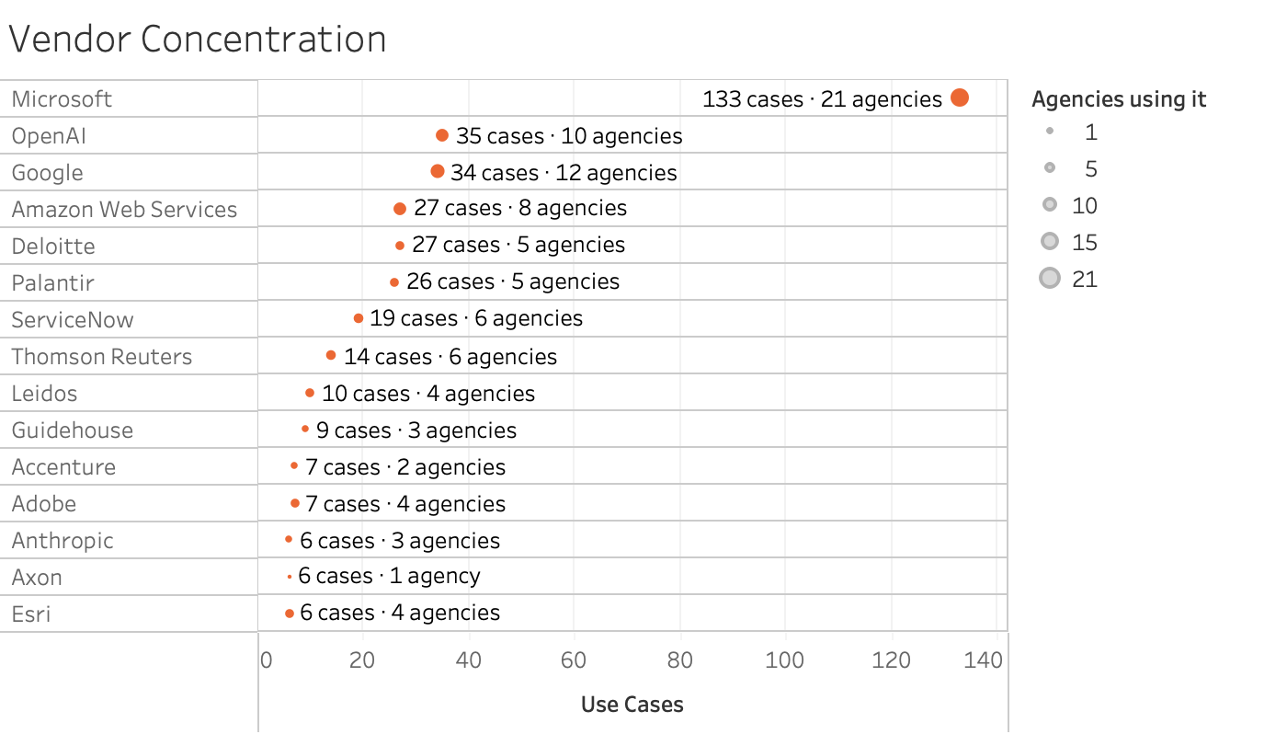
Prototype 3 (dot plot), question 3. Microsoft appears in 133 use cases across 21 agencies, far ahead of OpenAI at 35 use cases across 10 agencies and Google at 34 across 12 agencies. The chart shows both the number of use cases naming each firm and the number of agencies using it. The uncertainty is that vendor names are free text, a use case may name several firms, and the field is reported only for pilot and deployed cases with vendor involvement.

4. Semester Portfolio Plan
Understanding the problem. Descriptive views establish what federal AI is, including the growth from 710 to 3,611 reported use cases and the mix of technologies, and the scale of the 2025 workforce reduction.
Exploring the evidence. Relationship and change-over-time views extend the prototypes. Linking each 2024 use case to its 2025 record traces which pilots were deployed and which disappeared; a first pass suggests only one in seven 2024 pilots was reported as deployed. Monthly hires and exits for data scientists show the pipeline closing, and exit routes show that deferred resignation was the largest route out of every technical occupation. Further views cover vendor concentration and the age profile of IT staff.
Considering implications. Read together, the evidence shows AI that is often bought, with many pilots that never reach deployment, alongside a technical workforce that stopped hiring and is older than the rest of government. The interactive product will have two views: an AI explorer that filters use cases by agency, stage, type of AI, and build strategy, and a workforce explorer that shows hires, exits, and headcount for each technical occupation.
The design system stays fixed: orange for AI and vendors, blue for people and in-house work, gray for what is missing from the record. The central claim is disputable and testable: federal AI is limited less by how many tools agencies adopt than by whether the government has the people to carry them past the pilot.

5. AI Use and Verification
I used generative AI to help combine and clean files within each source, including standardizing field names, categories, and agency identifiers. During exploratory data analysis, I also used AI to suggest feasible visualization approaches for reference. I reviewed the data and selected and verified the final analyses and Tableau designs myself.

